**Course Project   
DeVry University  
College of Engineering and Information Sciences**

**Course Number: CEIS236**

**Course Project Deliverable: 5**

Include screenshots of the code and result

## Problem 1

Write the SQL code that will create only the table structure for a table named EMPLOYEE. The basic table structure is summarized in the following table. Use EMP_NUM as the primary key. **Your code should also prevent null entries in EMP_LNAME and EMP_FNAME.** Take a screenshot of the code. (hint: when creating the EMP_HIREDATE field, use the DATE datatype and not the DATETIME datatype since we only want dates and not date/times.)

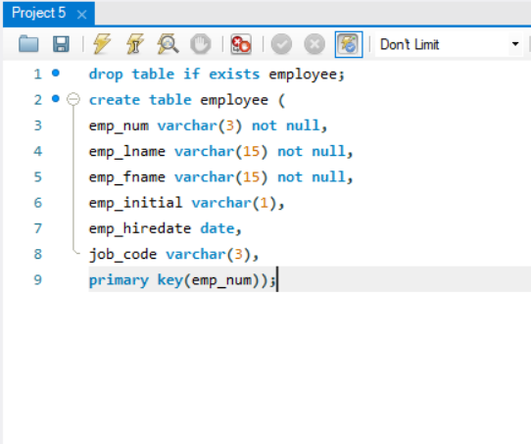

## Problem 2

Having created the table structure in Problem 1, write the SQL code to enter the five rows for the table shown in the following figure. Each row should be inserted individually, without using a subquery. Insert the rows in the order that they are listed in the figure. Also note that the first row needs to contain **YOUR** last name and **YOUR** first name. Take a screenshot of the code and EMPLOYEE table after entering the data. (hint: run this select query to show all records: **select * from employee;** )

## Problem 3

Write the SQL code to change the job code to 501 for the person whose employee number (EMP_NUM) is 103.

## Problem 4

Write the SQL code to create a copy of EMPLOYEE, including all of its data, and naming the copy EMP_2.

**Problem 5**

Using the EMP_2 table, write the SQL code that will add the attributes EMP_PCT and PROJ_NUM to EMP_2. The EMP_PCT is the bonus percentage to be paid to each employee. The new attribute characteristics are:

EMP_PCT DECIMAL(4,2)  
PROJ_NUM CHAR(3)

Note: If your SQL implementation requires it, you may use NUMBER(4,2) or NUMERIC(4,2) rather than DECIMAL(4,2).

## Problem 6

Using the EMP_2 table, write a single SQL command to change the EMP_PCT value to 5.00 for the people with employee numbers 101, 102, and 105 (hint: use the IN keyword).

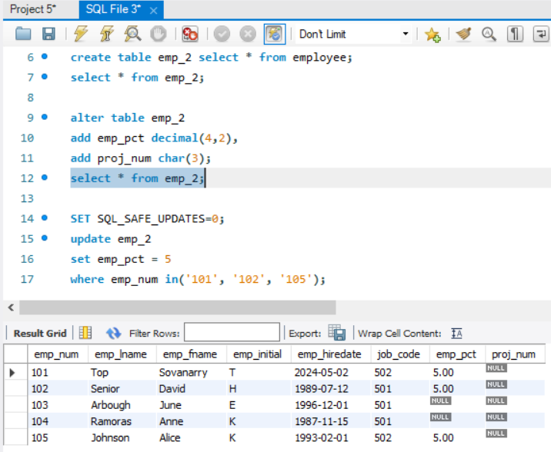

## Problem 7

Write the SQL code to join the PRODUCT and VENDOR tables using common attributes. Display the result sorted by price.

## Problem 8

Write the SQL code to display the total inventory. Your query should retrieve the product code, description, and the calculated total inventory. This will be calculated by multiplying P_QOH by P_PRICE and rounded to two decimal places. The new field should be named TOTAL_INVENTORY. Sort by TOTAL_INVENTORY descending.

## Problem 9

Write the SQL code to display the customer last name, first name, invoice date, and line price from CUSTOMER, INVOICE, LINE. Join all three tables and display only those values with a line price less than 10.

## Problem 10

Write a query to count the number of customers with a balance of more than $500.

